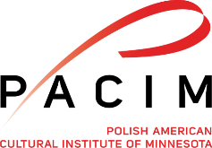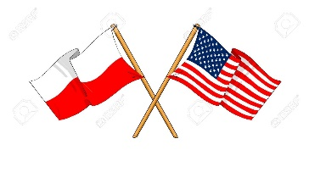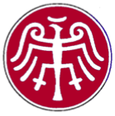
American Council for Polish Culture
70th Annual Convention
August 08-12, 2018
Crowne Plaza Northstar Hotel
Minneapolis, Minnesota

Convention Hosts - Polish American Cultural Institute of Minnesota (www.pacim.org)
Hotel Reservations
- Make room reservations directly with the hotel
- Convention room rate is $129.00 plus tax, single or double
- Hotel reservation contact line is 800-556 7827
- Online website reservation at www.cpminneapolis.com
- Group rate code is PAC
Convention Delegate Registration (see below)
- Payment by check only for total amount
- $250 deposit will be accepted prior to 07/01/18
- Total payment must be received by 08/01/18
- All checks to be made out to PACIM – ACPC
Mail to: PACIM, 43 Main St. SE, Suite 228, Minneapolis, MN 55414
Questions: phone 612-378-9291 or email office@pacim.org _____________________________________________________________2018 ACPC Registration Form
August 08,2018 arrival $475________
August 09,2018 arrival after lunch $375________
August 10,2018 arrival after lunch $325________
August 09,2018 Sembrich concert - Guest ticket $30________
August 10,2018 Awards banquet - guest ticket $75________

Names: ______________________________________________________
Club: ________________________________________________________
Address: _____________________________________________________
City/State/ Zip Code: ___________________________________________
Phone: ________________ Email: _______________________________

